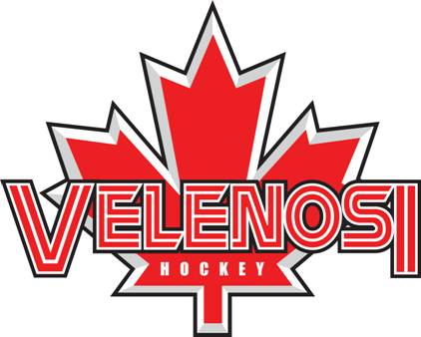

Day Clinic
Caledonia
Every Wednesday starting March 10th
For 5 weeks
4:00pm to 5:00
Ages 2013 to 2009
No beginners at this time
100 Haddington St, Caledonia, ON N3W 2N4
Skating and Resistance Training
Stickhandling and Shooting Skills
Velenosi Power Skating and Hockey Development Each session will include proper Power Skating Skills with Stick and Puck Control, Resistance Training, Stickhandling and Shooting Skills. Full equipment, stick and water bottle will be needed. Skaters will be grouped by level. Contact info@velenosihockey.com for more information.
*To become a complete Hockey Player, “SKATING” is the name of the game!! Speed, Balance, Lateral Movements, Agility, Quick Turns, Explosive Starts, Fast Stops, Deeks, Backward development is the “Velenosi Way of Skating” Our on-ice resistance program will increase your child’s Speed, Strength and Stamina!! Our Stickhandling and Shooting Skills, will complete your child’s hockey development training.
CELEBRATING OVER 35 YEARS IN THE AREA
About You… *must be in a hockey program
Name: Age: Date of Birth: (m) (d) (y)
Last Level of Hockey: AAA AA A/Hub AE Select House League
Last VPS Clinic: Day of Week: Time: Year:
Home Phone: ( ) - - Cell: ( ) - - Work: ( ) - - ext.
Email 1: Email 2:

Full equipment, stick and water bottle.
The undertaking of these actions cannot guarantee you and/or child will not become infected with COVID-19. Further, attending these activities could increase your risk of contracting COVID-19. By signing this agreement I acknowledge the contagious nature of COVID-19, and assume the risk that my child/children and I may be exposed to or infected by COVID-19 while attending activities in the facility. I understand that the risk of becoming exposed to or infected by COVID-19 at the facility may result from the actions, omissions or negligence of myself and others including Velenosi Hockey Development.
--------------------------------------------------------------
Payment Instructions
Please make payment on first day for the first three skates. We will then charge the next two skates closer to the day. Cost is $40.00 plus tax per skate.
No refunds
Consent…
I give my consent to my participation in all activities of the Velenosi power skating skills, hockey development, and resistance training (Velenosi Hockey Development), and agree that the school and/or its proprietors, staff, directors and any other person or corporation connected herewith from all manner of action, injury, loss, damages, costs, however caused by participation in this program on or off the ice and agrees to release the proprietors, staff, directors and any other person or corporation from all claims or damages which as a result of or by reason by such accidents or loss. This release shall be binding on our heirs, spouses, assigns, executors and administrators. I understand that all participants must wear full CHA approved hockey equipment during all on ice activities. V.H.D. is not responsible for ice cancellations due to bad weather or situations not under our control.
Parent/Guardian Signature_______________________________________Dated__________________________

