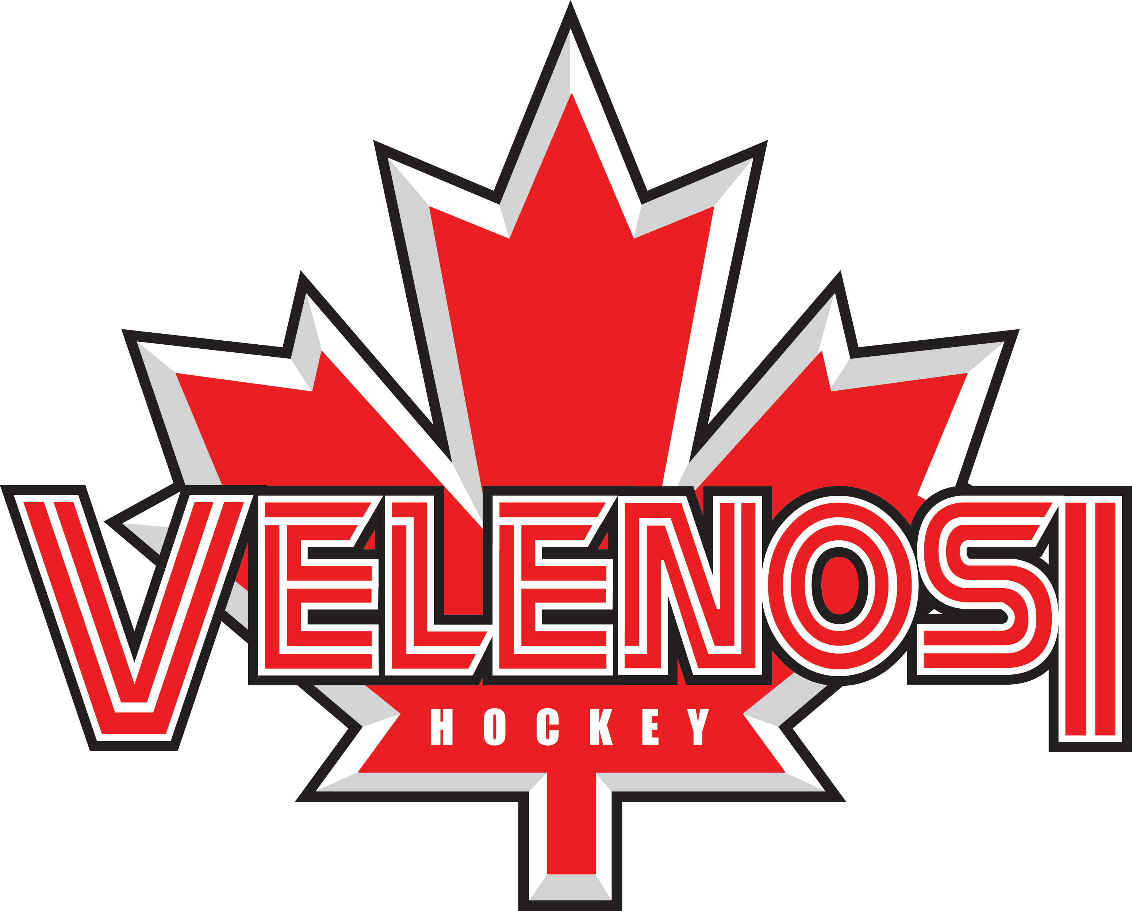
LEARN TO SKATE CLINIC
SPRING/SUMMER
FOR BOYS AND GIRLS OF ALL AGES
CHOOSE MONDAYS OR TUESDAYS
STARTING WEEK OF MONDAY MAY 13TH - JULY 30th 2019( 10 WEEKS) 4:45-5:45
TUESDAY MAY14TH-JULY 30TH2019(10 WEEKS) 4:45-545
Classes will be held at the Mohawk 4 Ice Centre
CELEBRATING OVER 40 YEARS OF QUALITY SKATING INSTRUCTION
About You
Name: Age: Date of Birth: (m) (d) (y)
Home Phone: ( ) - - Cell: ( ) - - Work: ( ) - - ext.
Email 1: Email 2:

THIS CLINIC IS FOR BOYS AND GIRLS OF ALL AGES INTERESTED IN LEARNING BASIC SKATING SKILLS. HELMET WITH CAGE, MITTS/GLOVES, KNEE PADS AND ELBOW PADS WILL BE NEEDED.FULL HOCKEY EQUIPMENT IS WELCOME AS WELL.
Please Select Mondays or Tuesdays
Mondays ____4:45pm-5:45 Tuesdays_____4:45pm-5:45
Please Select Age Group
(A)____AGES 3-5 (B) ____AGES 6-9 (B) ___AGES 10+
This Clinic is designed for beginners of all ages focusing on basic skill development. Sandy Velenosi and the V-Team Staff will instruct the skaters on the fundamentals in skating preparing all skaters for hockey, ringette, figure skating or just for fun!!

Payment Instructions
Please include full payment of $350.0.00 plus h.s.t. $45.00 = $395.50
or 5 post-dated cheques in the amount of $79.10 dated March 15/19, April 15/19 , May 15/19, June 15/19,July 15/19
or pay credit card

MC VISA Name………………………………..#............................................Expiry…………..Amount………………
*10.00 administrative fee will be added to all cc payments
mail to: or drop off at the “Velenosi” mail box
Velenosi Power Skating c/o Mohawk 4 Ice Centre (beside the sports store at the Quad)
710 Mountain Brow Blvd, Hamilton L8T 5A9 or email with attachment info@velenosihockey.com
*please call the rink 905-318-5111 in case of bad weather…classes will only be re-scheduled if rink closes
- No refunds/credit only
www.velenosihockey.com or info@velenosihockey.com
Consent
I give my consent to my participation in all activities of the Velenosi learn to skate and agree that the school and/or its proprietors, staff, directors and any other person or corporation connected here with from all manner of action, injury, loss, damages, costs, however caused by participation in this program on or off the ice and agrees to release the proprietors, staff, directors and any other person or corporation from all claims or damages which as a result of or by reason by such accidents or loss. This release shall be binding on our heirs, spouses, assigns, executors and administrators. I understand that all participants must wear full CHA approved hockey equipment during all on ice activities. Velenosi hockey development is not responsible for ice cancellations due to bad weather or situations not under our control.
Parent/Guardian Signature_______________________________________Dated__________________________

*

