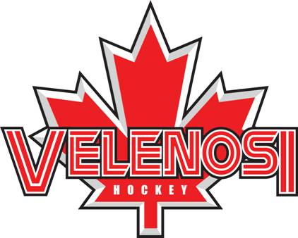

Day Clinic
Caledonia
100 Haddington St, Caledonia, ON N3W 2N4
CELEBRATING OVER 35 YEARS IN THE AREA
About You… *must be in a hockey program
Name: Age: Date of Birth: (m) (d) (y)
Last Level of Hockey: AAA AA A/Hub AE Select House League
Last VPS Clinic: Day of Week: Time: Year:
Home Phone: ( ) - - Cell: ( ) - - Work: ( ) - - ext.
Email 1: Email 2:

Full equipment, stick and water bottle.
🔥 In Caledonia/Haldimand Hockey Development - Fall/Winter Program 🔥Boys and girls welcome. AAA/MD/AA/BB/Select and House must be able to skate
No beginners at this time
Dates: November 13, 20, 27 | December 4, 11, 18 | January 8, 15, 22, 29 | February 5, 12
Mondays 430-5:30
Skills Covered:
✅ Powerskating. ✅ Edge Work Practice
✅ Resistance Training. ✅ Deeking Skills
✅ Offensive and Defensive Training
✅ Shooting Techniques. ✅ Mastering Backwards Skating
✅ Stickhandling Drills ✅ Quick Feet Starts and Stops✅ Quick Turns
For more information and to reserve your spot, email us at Info@Velenosihockey.com.
Cost $420 plus hst
Walk ons $50 if spots are availabe
--------------------------------------------------------------
Payment Instructions
Cost 420 plus hst $474.60
Etransfer Name: ___________________________________Date_________________________
Visa:__________________________number_____________________________exp__________
Consent…
I give my consent to my participation in all activities of the Velenosi power skating skills, hockey development, and resistance training (Velenosi Hockey Development), and agree that the school and/or its proprietors, staff, directors and any other person or corporation connected herewith from all manner of action, injury, loss, damages, costs, however caused by participation in this program on or off the ice and agrees to release the proprietors, staff, directors and any other person or corporation from all claims or damages which as a result of or by reason by such accidents or loss. This release shall be binding on our heirs, spouses, assigns, executors and administrators. I understand that all participants must wear full CHA approved hockey equipment during all on ice activities. V.H.D. is not responsible for ice cancellations due to bad weather or situations not under our control.
Parent/Guardian Signature_______________________________________Dated__________________________

